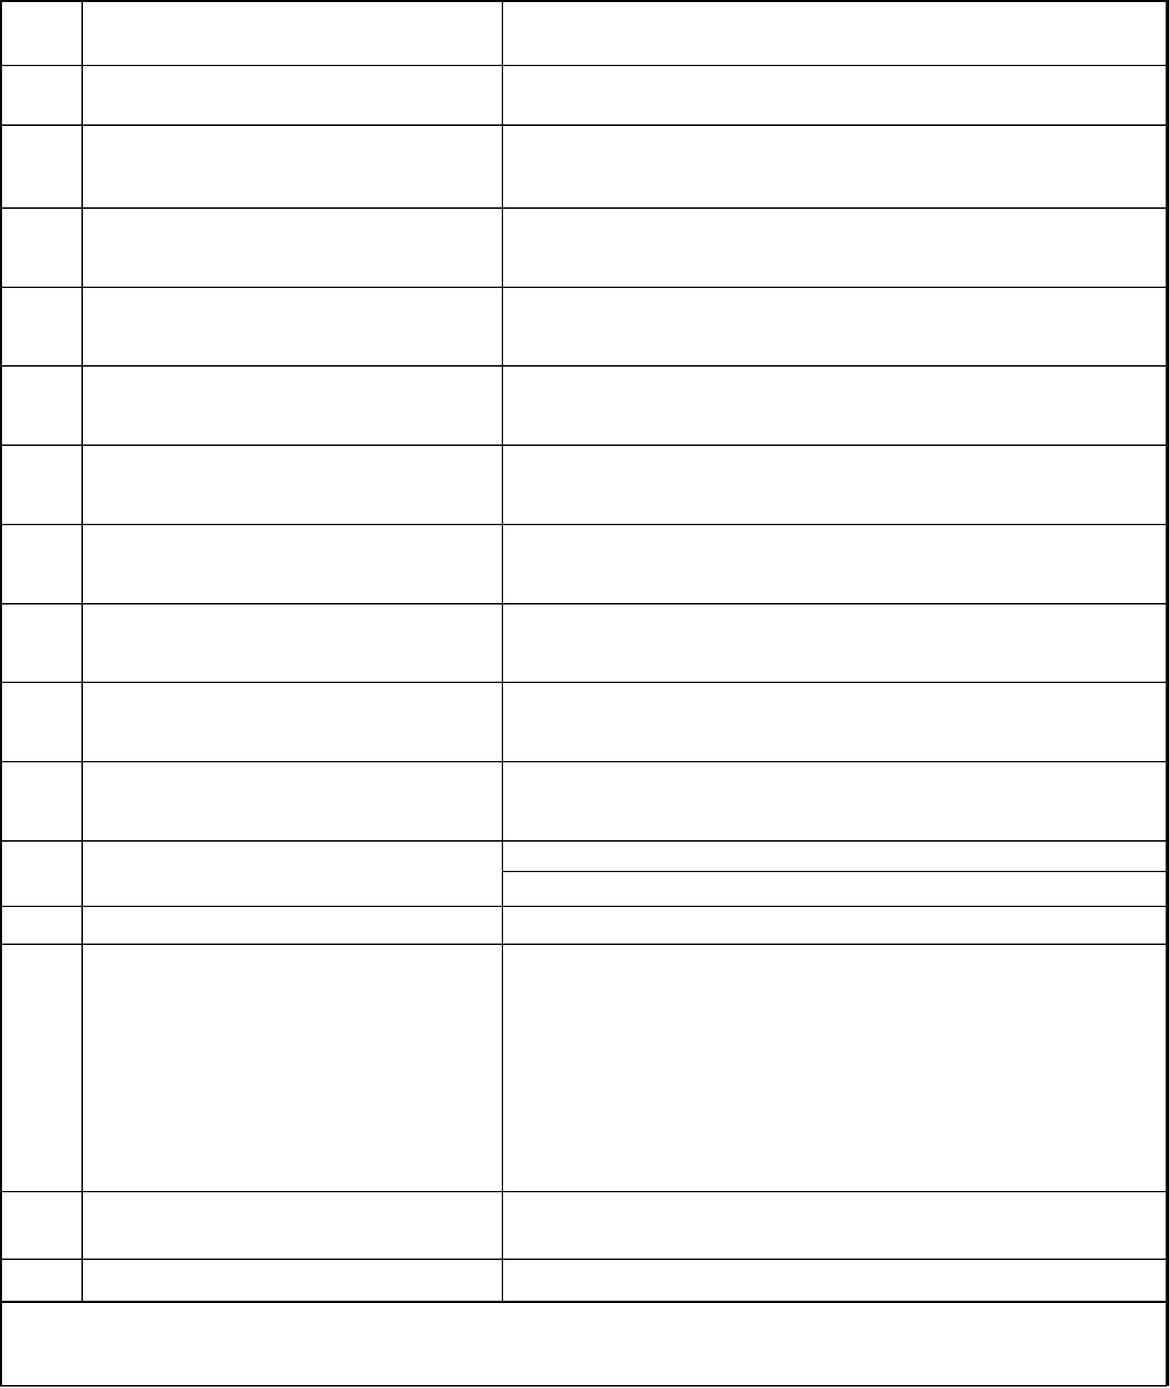
On the Letter Head of the Company
KNOW YOUR CUSTOMER (KYC) FORM
To,
Date:
Hyundai Merchant Marine India Pvt. Ltd
Sr. No. Particulars
TO BE FILLED BY CONSIGNEE
1
2
Name of the Consignee
Address of the consignee
Nature of Business(Partnership/ Pvt/
Public/Individual/Trust/Foundation)
3
4
Date of Establishment
IEC No. of Consignee
Permenant Account No. (PAN)
Office Contact Number
Office FAX Number
Office Website Address
E-mail ID
5
6
7
8
9
10
Mobile No. :
Mobile No. :
11
12
Escalation Contact
GST RegistrationCertificate
- IEC Copy (Self Attested)
- Telephone Bill (Landline)/ Electricity Bill (Latest) (Self Attested)
- Pan Card Copy (Self Attested)
- AADHAR Card , Election ID Card, PassPort.(Of the Auth. Signatory) (Self
Attested)
13
Documents Enclosed
- GST RegistrationCertificate (Self Attested)
Company Registeration certificate
-
-
Signature Verification to the authorised signatory .
14
15
Full Name of the Authorised Signatory
Place of Submission
I/We hereby declare the above information is true & correct, In case of any changes in the above details, we agree to keep your office
informed and re-submit the relevant documents along with the revised KYC form.

Authorised Signature with Company Seal

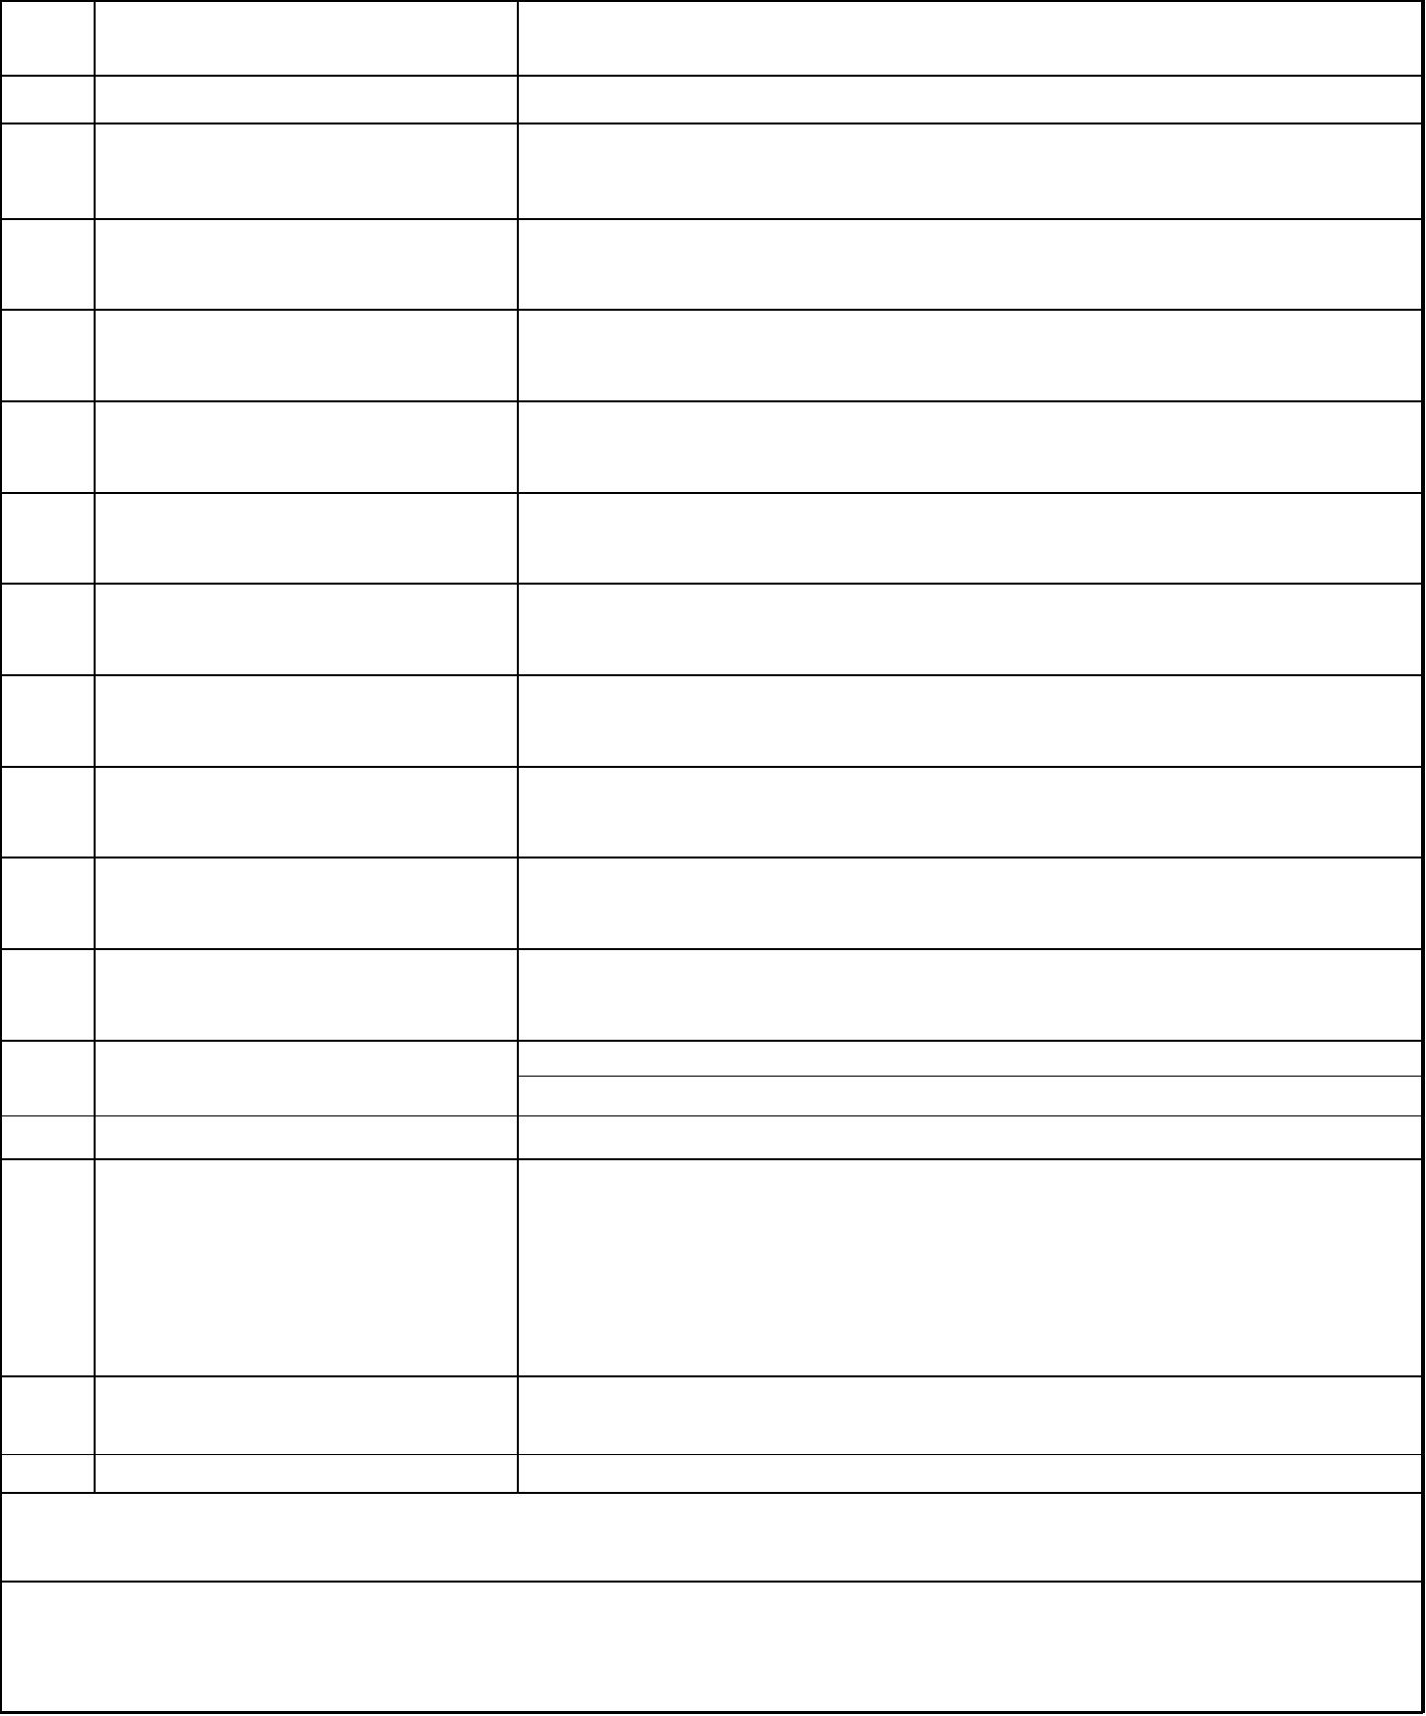
On the Letter Head of the Company
KNOW YOUR CUSTOMER (KYC) FORM
To,
Hyundai Merchant Marine India Pvt. Ltd
Date: ___________
Sr. No. Particulars
TO BE FILLED BY FORWARDER
1
2
Name of the Forwarder
Address of the Forwarder
Nature of Business(Partnership/
Proprietorship/ Pvt/Public/
Individual/Trust/Foundation)
3
4
Date of Establishment
MTO Licence Number
IEC No. of Forwarder
Permenant Account No. (PAN)
Office Contact Number
Office FAX Number
5
6
7
8
9
10
11
Office Website Address
E-mail ID.
Mobile No. :
Mobile No. :
12
13
Escalation Contact
GST RegistrationCertificate
- IEC Copy (Self Attested)
- Telephone Bill (Landline)/ Electricity Bill (Latest) (Self Attested)
- Pan Card Copy (Self Attested)
14
Documents Enclosed
- Driving licence, Election ID Card, PassPort.(Of the Auth. Signatory) (Self Attested)
- GST RegistrationCertificate (Self Attested)
15
16
Full Name of the Authorised Signatory
Place of Submission
I/We hereby declare the above information is true & correct, In case of any changes in the above details, we agree to keep your office informed
and re-submit the relevant documents along with the revised KYC form.
Authorised Signature with Company Seal

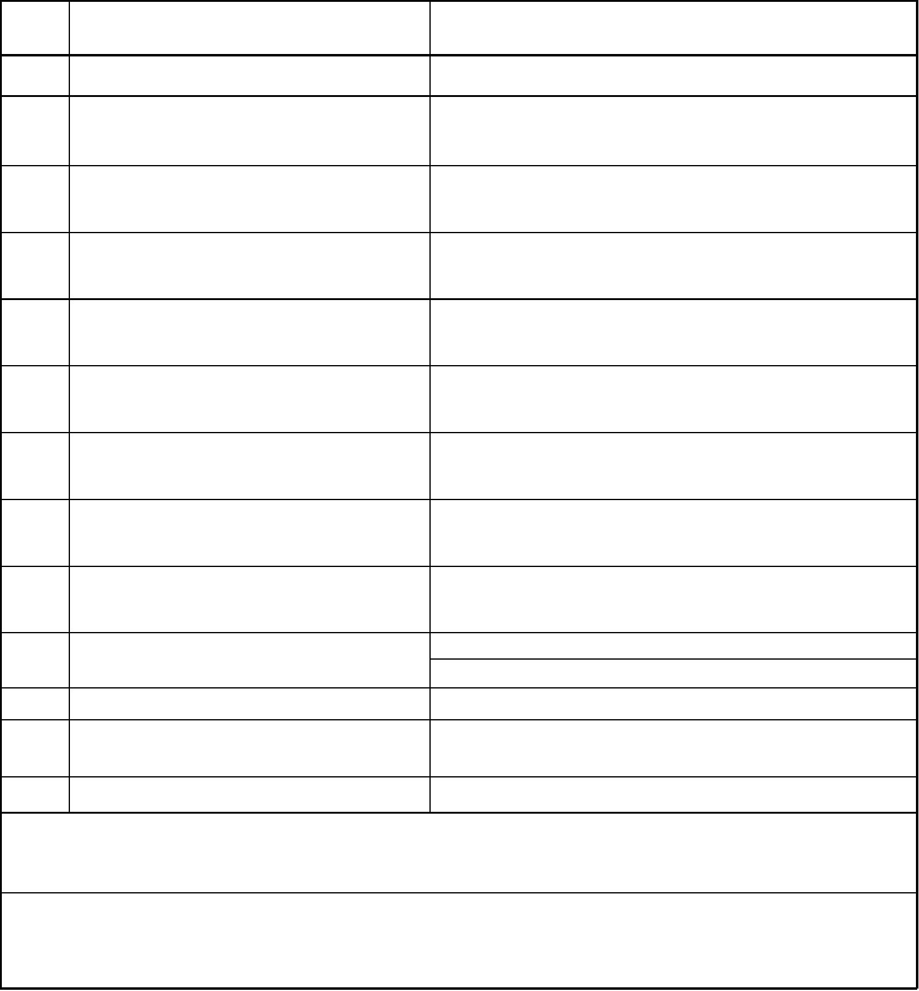
On the Letter Head of the Company
KNOW YOUR CUSTOMER (KYC) FORM
To,
Hyundai Merchant Marine India Pvt. Ltd
Date: ___________
Sr. No. Particulars
TO BE FILLED BY CUSTOM HOUSE AGENT (CHA)
1
2
Name of the CUSTOM HOUSE AGENT (CHA)
Address of the CUSTOM HOUSE AGENT (CHA)
3
4
5
6
7
8
9
CHA Licence Number
Date of Establishment
Permenant Account No. (PAN)
Office Contact Number
Office FAX Number
Office Website Address
E-mail ID for Receiving E- D/o & Import
Queries.
Mobile No. :
Mobile No. :
10
11
12
Escalation Contact
Service Tax Registration No.
Full Name of the Authorised Signatory
13
Place of Submission
We hereby certify that the aforesaid details are true and correct. Please find attached the CHA
Licence, PAN card copy duly attested by the Authorised Signatory of "Name of CHA".
In case of any change in above details, we agree to keep your office informed and re-submit the relevant documents along
with revised KYC form.
Authorised Signature with Company Seal

