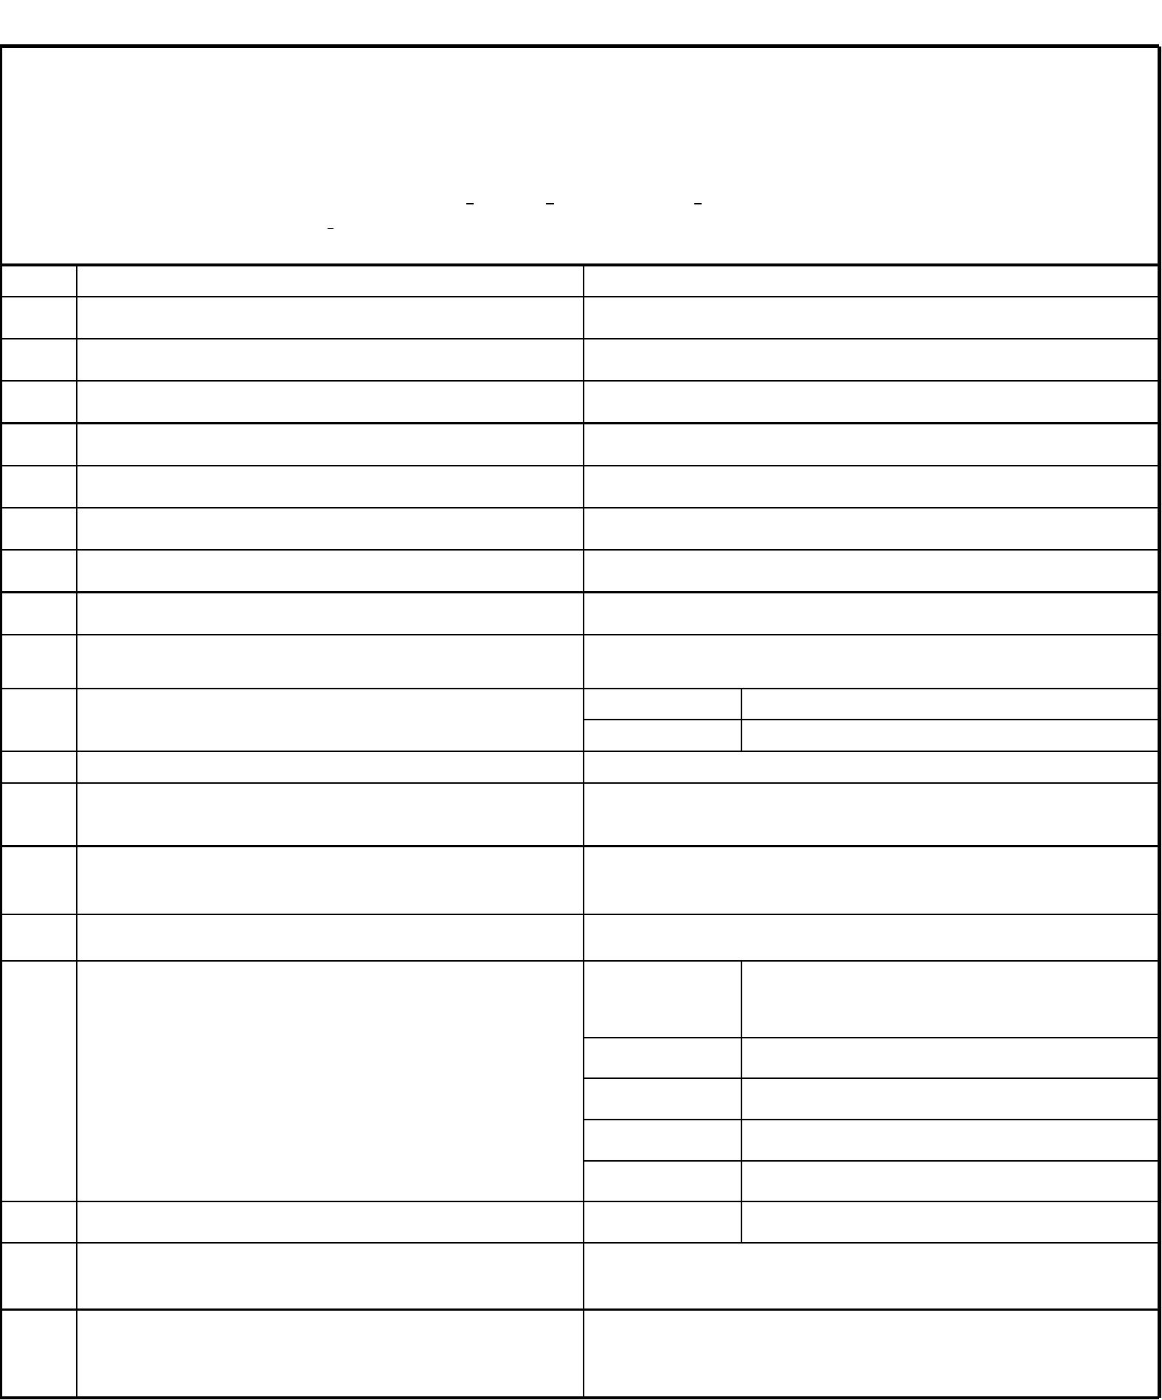

To
KNOW YOUR CUSTOMER FORM
Date :
Valid for one year only
Sl. No.
Particulars
(To be Filled by Client)
1
Name & Address of Shipper / Consignee / CHA
Constitution (Whether Pvt. Ltd., LTD., Partnership,
Proprietorship)
2
3
4
5
6
7
8
Date of Establishment
Permenant Account No. (PAN)
Value Added Tax Registration No. (VAT)
GST No.
Import / Export code
Nature of Business
Name and Address of Directors / Partners with DIN & Tel.
Nos. E-Mail id :
9
2017-2018
2018-2019
10
11
12
Turnover of the Company Sales( Rs.in 000's)
No. of employees
Name & Contact details of Accounts / Finance Head
Ahmedabad,Pune,Baroda,Nagpur,Delhi,Kanpur,Jaipur,Moradabad,Lud
hiana,Bangalore,Hyderabad,Tuticorin,Kochin,Chennai & Kolkata
13
14
Details of Branch offices of the Company
Name of Decision maker or person interacting on day to day
basis for business
Name & Address
Telephone No.
(Bank)
15
Bank Details
A/c. No.
MICR No. of the
Bank
RTGS Code No.
16
17
Copy of Canceled Cheque
Approximate Commited volumes in terms of TEUS, Freight
amounts & No of Shipments
I hereby declare the above information is true & correct.
Authorised Signature with Co. Seal
18
(To be filled up by shipping line name)
19
20
21
Signature of Sales Personnel Recommending the customer
Comments/approval of Dept. Head of shipping line name
Comments/approval of Dept. In-charge of shipping line
name

22
Remarks

